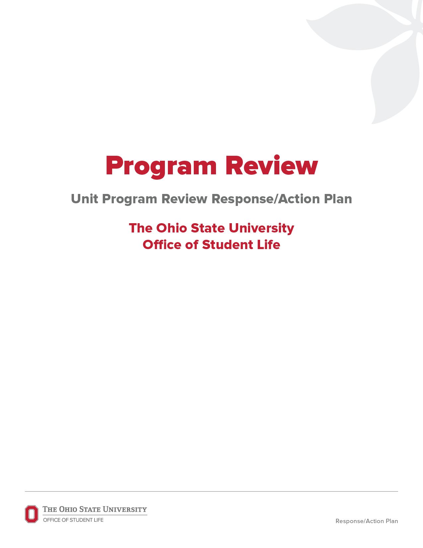

**Insert additional information here.**

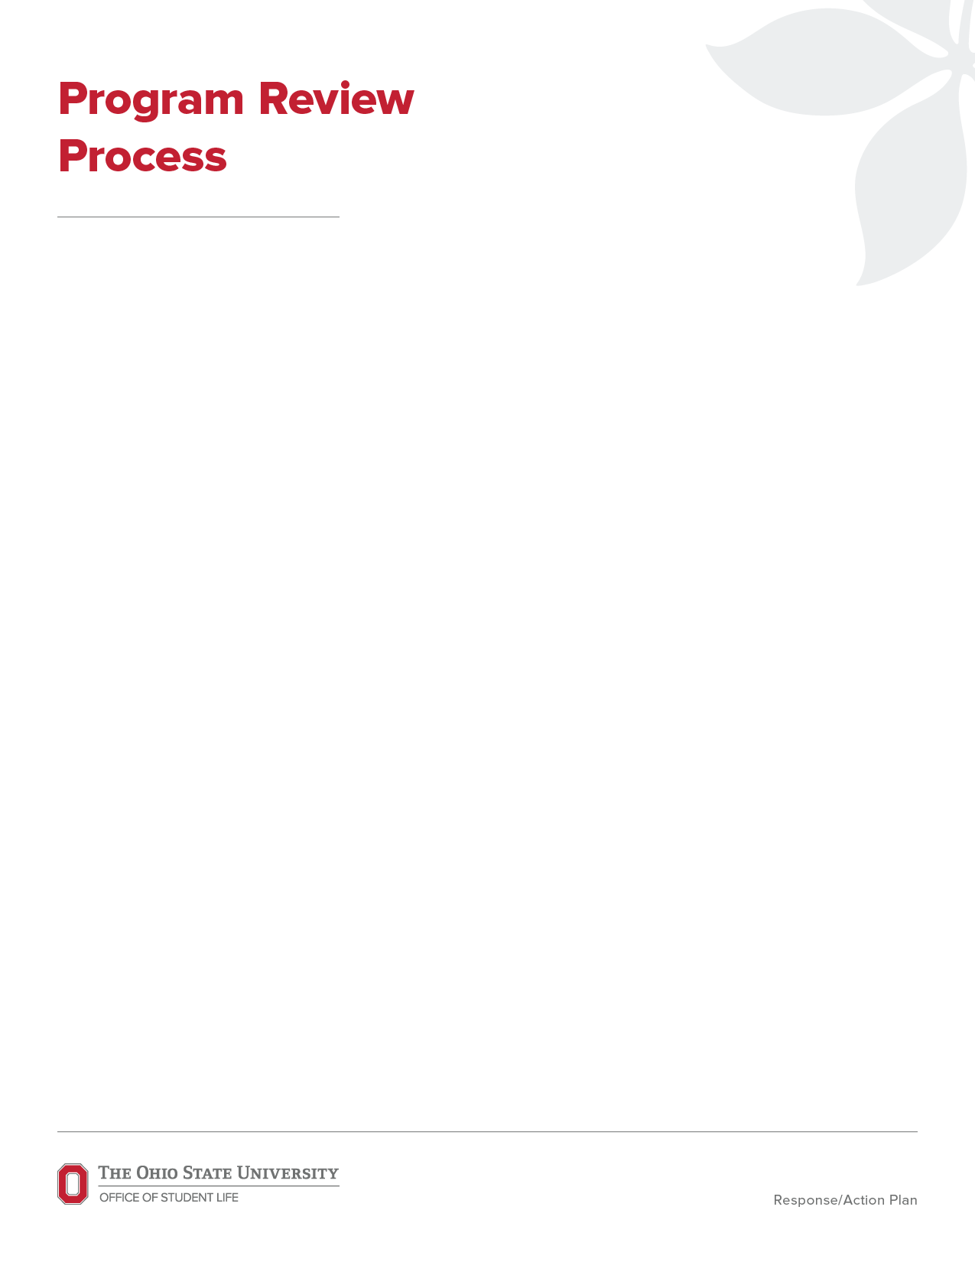

**Pre-Visit**

Provide a brief summary of actions taken to prepare the External Program Review Team

for their on-site visit.



**On-Site Visit**

Provide a brief summary of the events that took place during the on-site visit; e.g., the   
schedule of stakeholder and constituent meetings.



**Post Visit**

Provide a brief summary of events after the on-site visit; e.g., preparing Action Report.



**External Program Review Committee Members**

Provide names, titles, positions and institutions of External Committee Members.

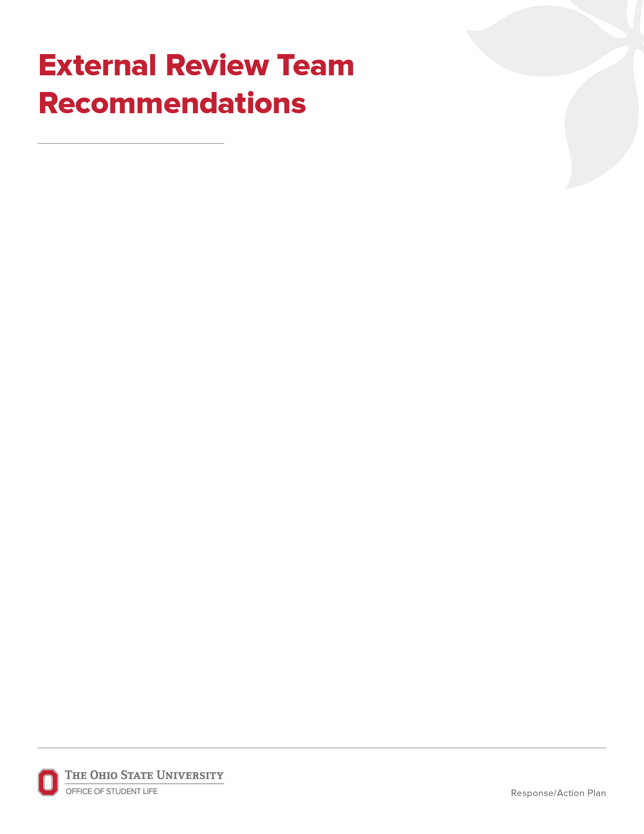

**Recommendation 1:**



**Recommendation 2:**



**Recommendation 3:**

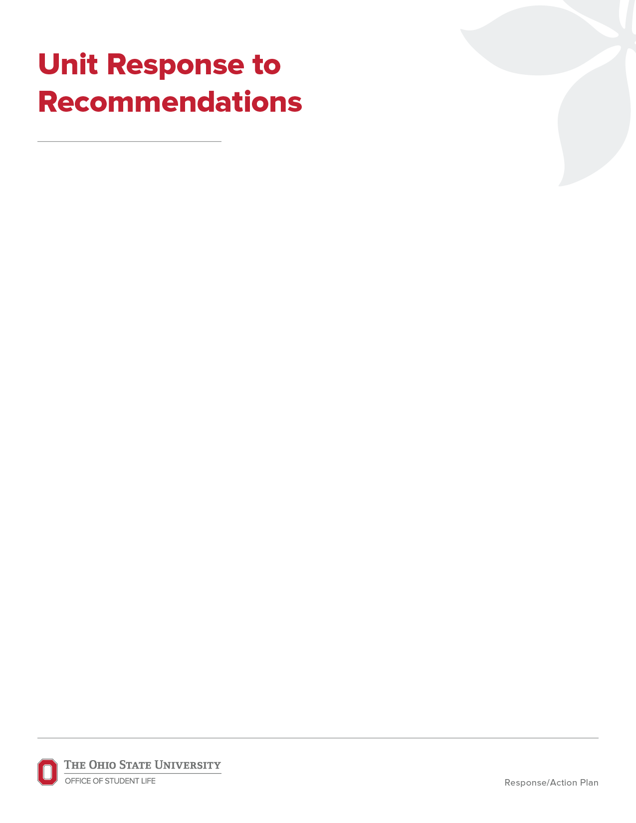

**Recommendation 1:**

Please address each recommendation with the following details:

1. Specific action steps, including where relevant staff members responsible for action steps
2. Measures of progress
3. Timeline for completion
4. Implementation strategy



**Recommendation 2:**

Please address each recommendation with the following details:

1. Specific action steps, including where relevant staff members responsible for action steps
2. Measures of progress
3. Timeline for completion
4. Implementation strategy



**Recommendation 3:**

Please address each recommendation with the following details:

1. Specific action steps, including where relevant staff members responsible for action steps
2. Measures of progress
3. Timeline for completion
4. Implementation strategy

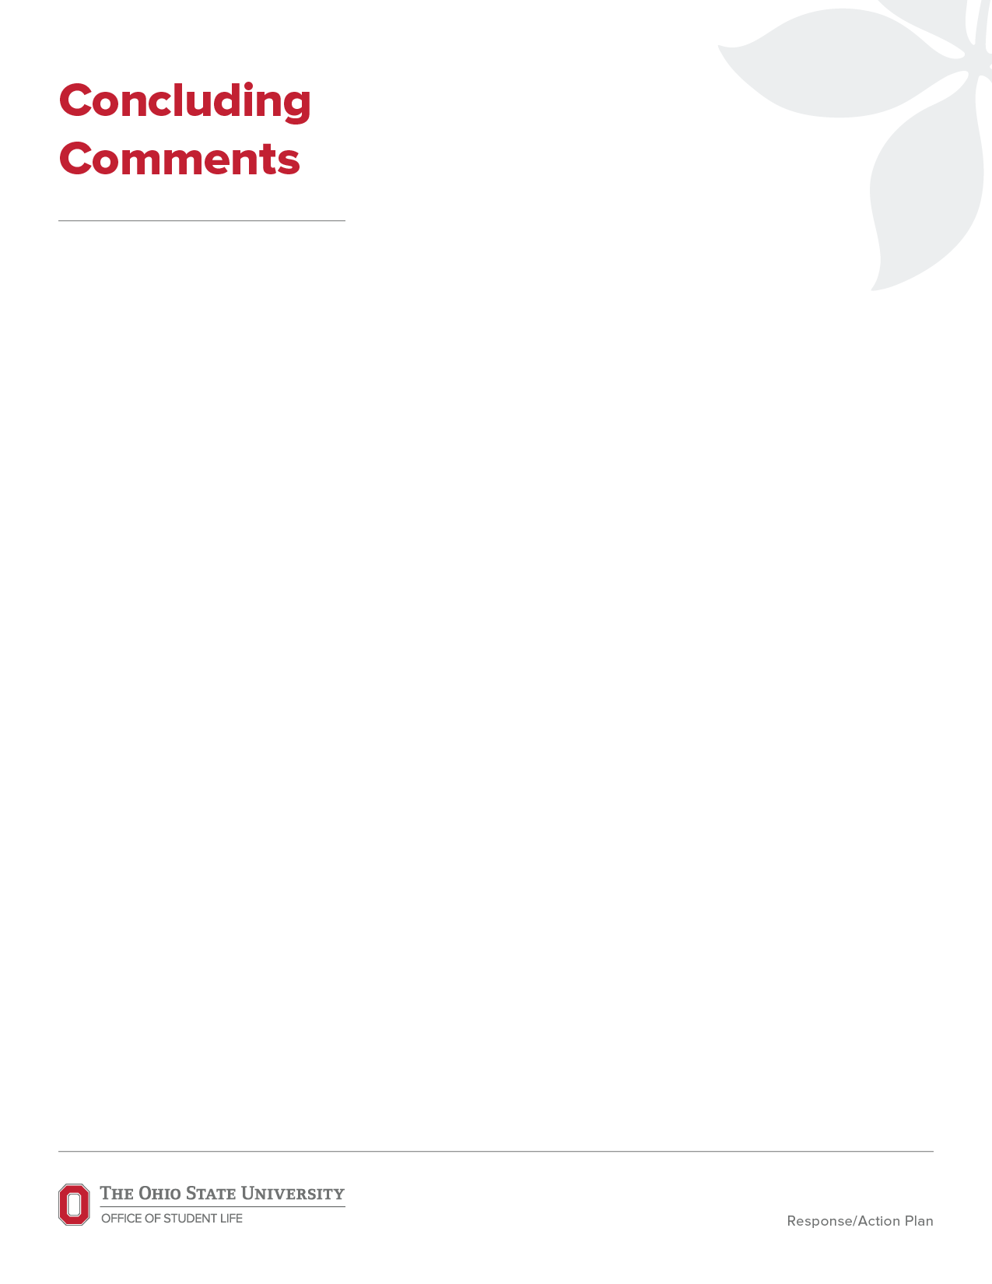

**Please provide a summary of action steps, additional   
details, remaining questions.**