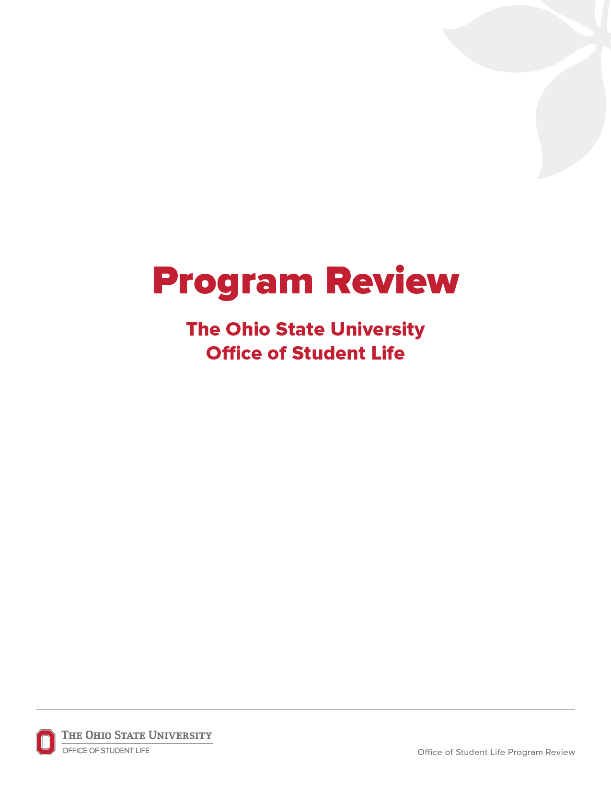

**Insert additional information here.**

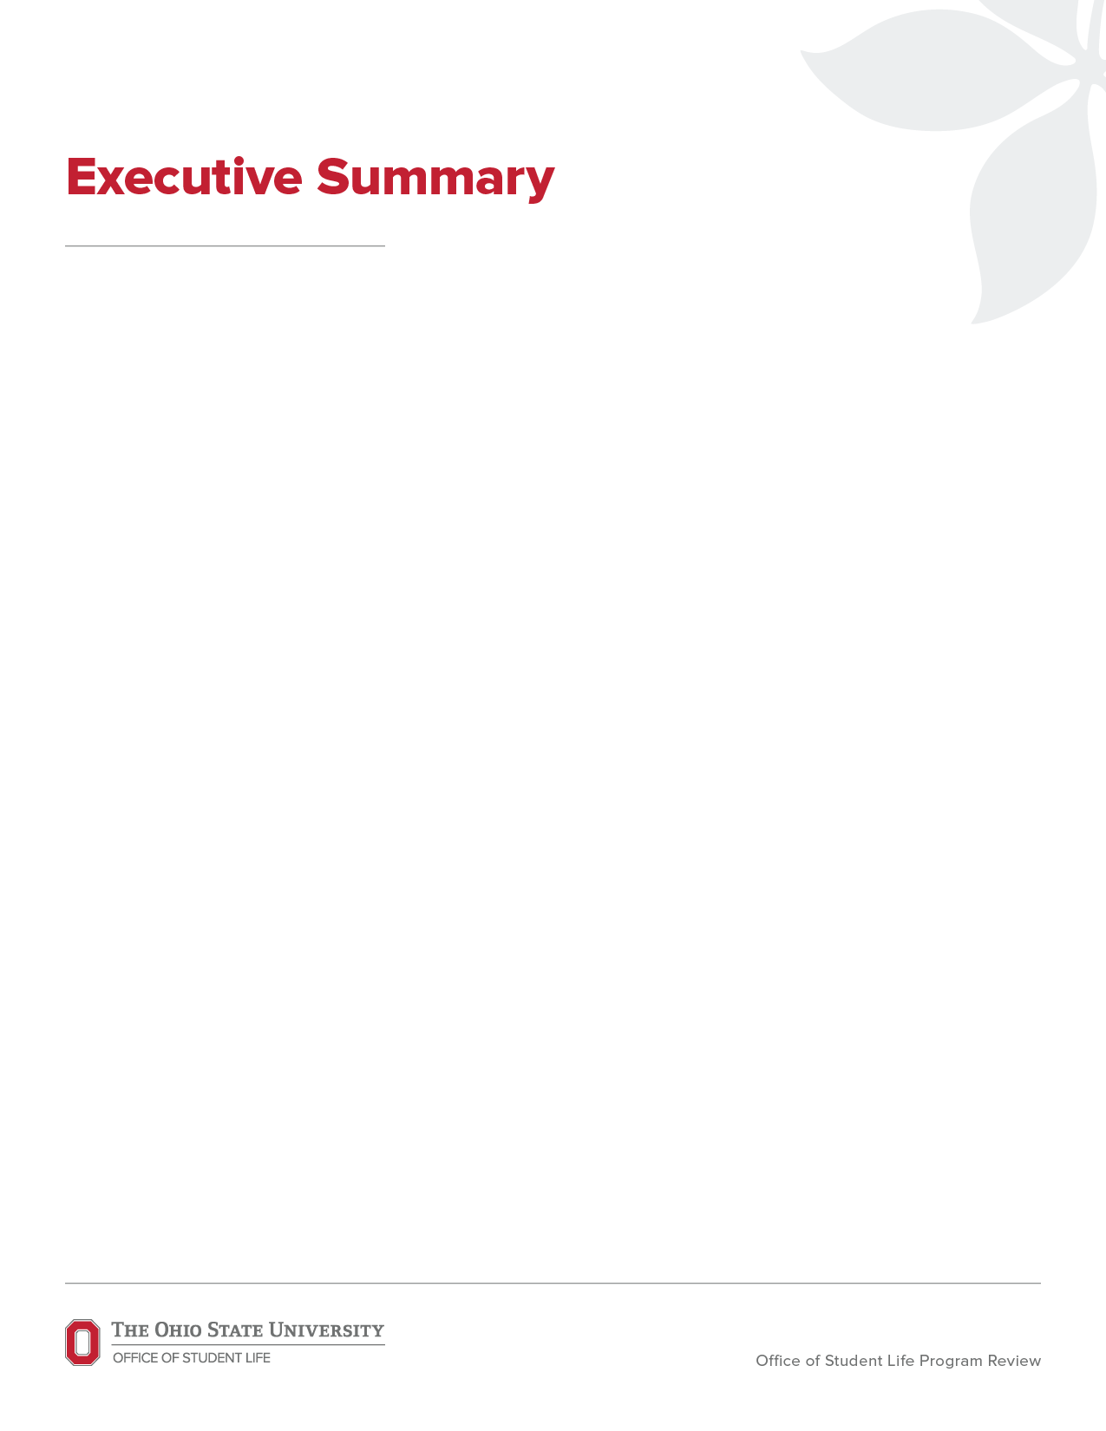

**Introduction**



**Areas of Strengths**

Please identify and discuss the functional areas in which the unit is performing well.



**Areas of Opportunities**

Please identify and discuss the functional areas related to opportunities and aspirations.

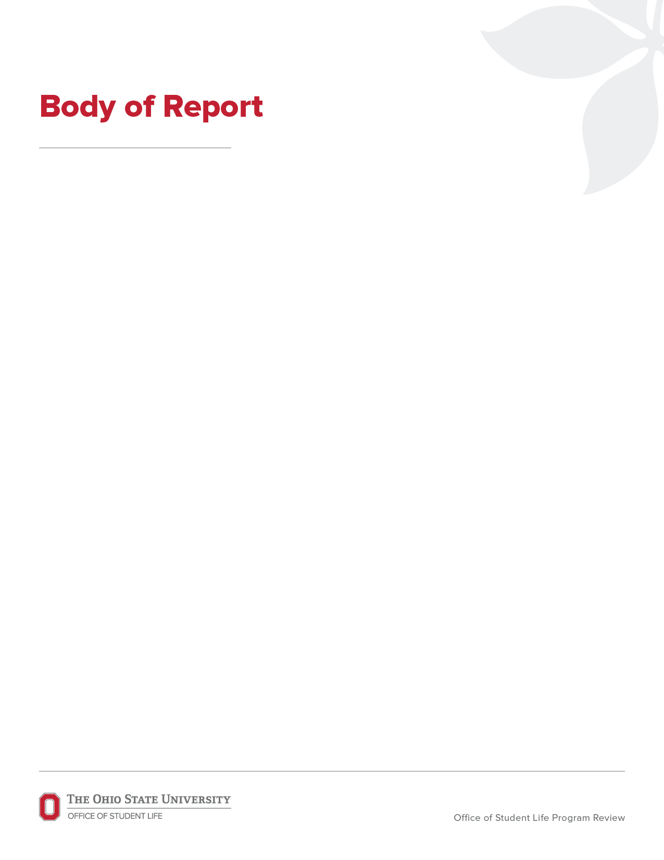

**Process**

Description of methods, process and timeline; e.g., delineating constituent and stakeholder

meetings and their panelists.



**Standard #**

(from specific unit Self-Study protocol) Please broadly address strengths, opportunities and recommendations for each applicable standard reviewed.



**Standard #**



**Standard #**



**Standard #**



**Other Findings**

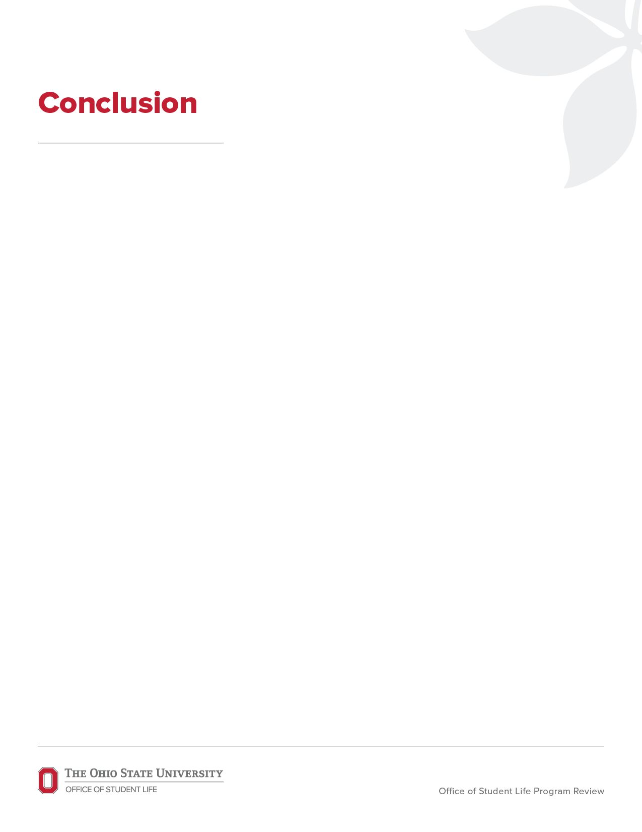

Please summarize the identified areas of strengths of the functional areas, areas of   
opportunities of the functional areas and share any additional comments for the continuous improvement of the unit. Include summaries if there are recommendations of changes   
to funding, staffing and/or programming.

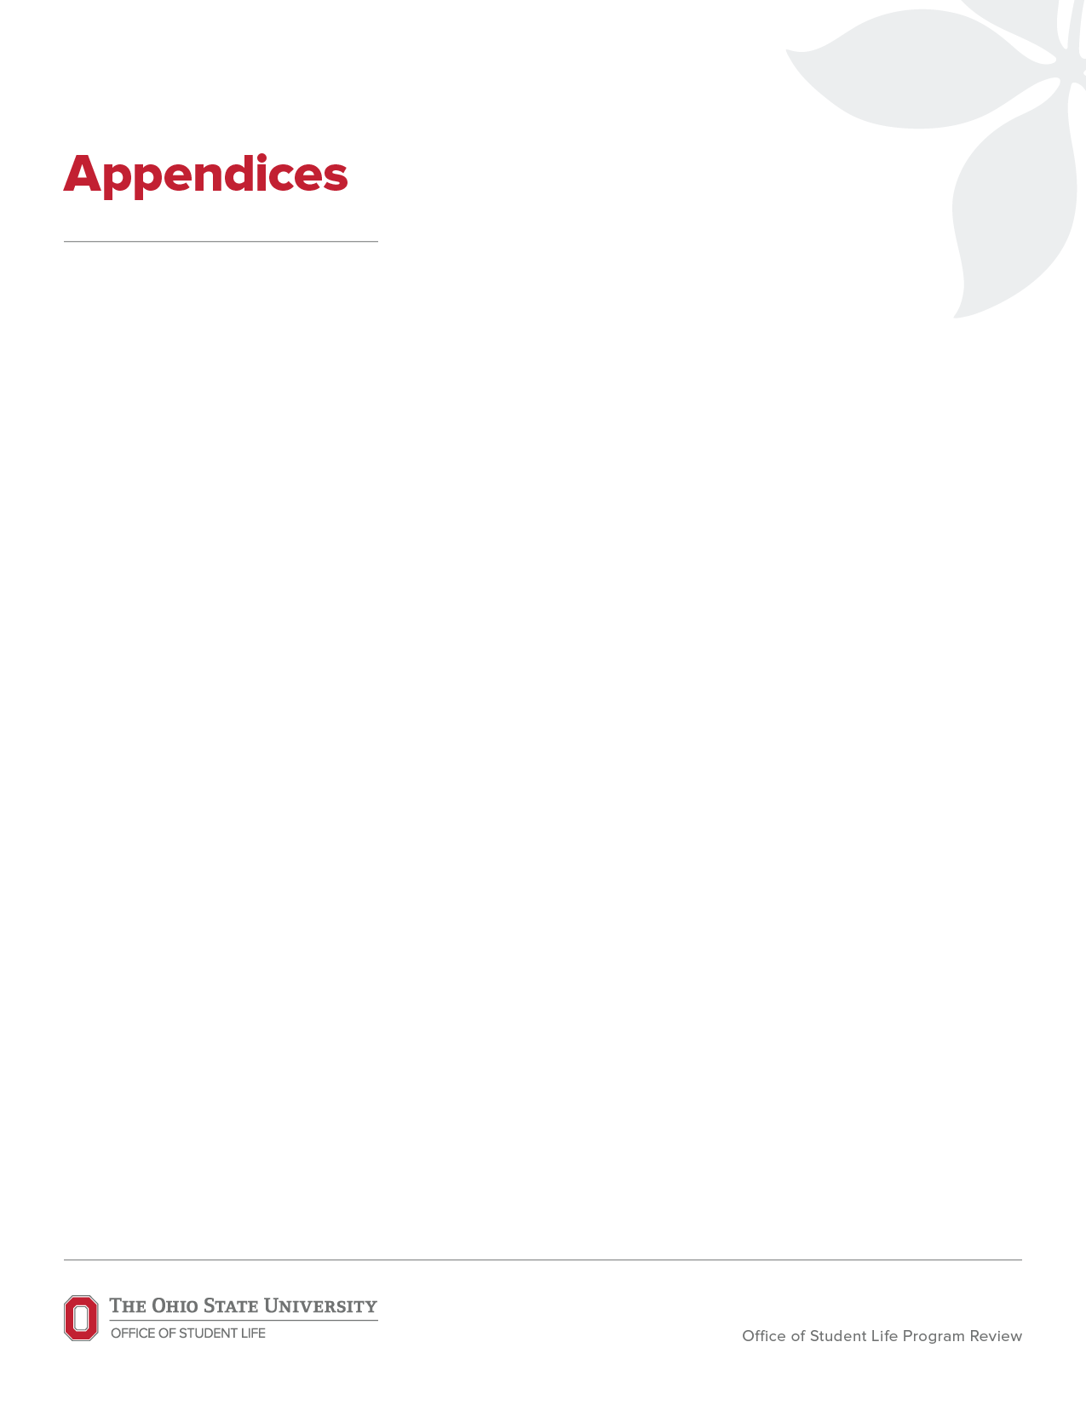

Insert additional items here, such as Committee member names and credentials, panelist

schedule and names, interview/focus group protocols, outside models.